In the reconstruction task, we only need to reconstruct face from the set train_X , right? Or we need to reconstruct face from test_X? The second one seems not true because we have built our W_pca_matrix from train_X dataset, so for the task of reconstruction, it seems not reasonable when we use W_pca_matrix built from train_X dataset to reconstruct face from test_X dataset.

2.
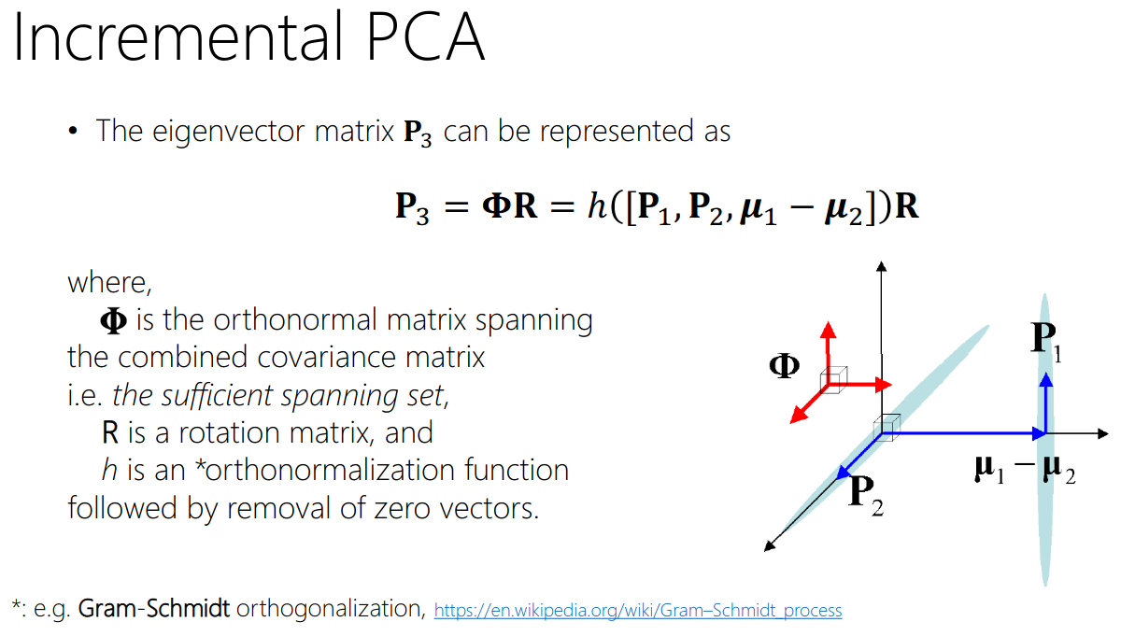

In the page 10 of lecture slide “online learning” , it mention about incremental PCA, it said that 𝚽= ℎ ([𝐏1, 𝐏2, 𝝁1 − 𝝁2]) where h is an *orthonormalization function followed by removal of zero vectors. AS far as I understand, if columns vectors of P1 are v1,v2,… v_d1, and columns vectors of P2 are m1,m2, … m_d2, then we need to collect d1+d2+1 vectors: v1,v2,… v_d1, m1,m2, … m_d2, 𝝁1 − 𝝁2. Then we apply Gram-Schmidt orthogonalization on these d1+d2+1 vectors to generate new d1+d2+1 vectors h1,h2,… h_(d1+d2+1) that span [𝐏1, 𝐏2, 𝝁1 − 𝝁2] and orthogonal to each other. But then, we need to remove some non-important vectors from h1,h2,..h_(d1+d2+1) and the remaining vectors will be used to form 𝚽 ( that mean these important vectors become column vectors of 𝚽. My first question is that among h1,h2,… h_(d1+d2+1), how to know which vector is non-important. My second question is that : if all of the above is true, then is it true that the number of column vectors of 𝚽 can be smaller than d1+d2+1 ? (because we have remove some non-important vectors)

3. In the Q1, we only apply PCA to the training data, so in the reconstruction task, does it mean that we only reconstruct face from training data? Or we need to reconstruct faces from test data?
4. In Q1, when I compute eigenvalues of covariance matrix, there is no zero-eigenvalue. But the question ask to count the number of non-zero eigenvalue.

5. How to compute face reconstruction error in Q3?

I think Reconstruction error can be computed by MSE error, which is in page 11 of Lecture 3.
=> Sorry. I meant the equation that looks like J= 1/N * sum(x_n-reconstructed_x_n))^2.

ok, so we flatten the original face and reconstructed face into 2 vectors, and then measure the distance of these 2 vectors, right?
=> Yes, right.

6. How are we going to use confusion matrix for the pca-lda?

I think that confusion matrix can be used to further analyze and visualize the classifcation result of pca-lda process. For instance, It could let you know that which face makes more error and which face is sparse, by only one image.

7. Can i use that GoogleDocs sheet to ask question about content in the lecture slides? Because some slides are related to the coursework1
Yes you can
@Dat Nguyen.

8. In the report, we just need to answer and explain our ideas and analysis for each question right? We don’t need to follow each section as IEEE paper right?

Yes. You don’t need to follow the section format of IEEE paper, exactly.

